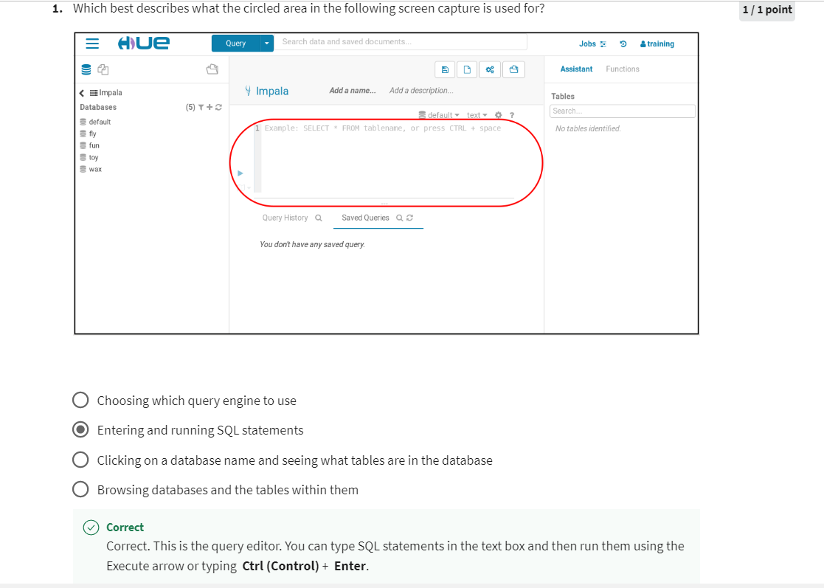

Question 2

Which steps in Hue will list the tables within a database?

Run **SHOW DATABASES** and then run **LIST TABLES**

Question 3

What are the steps to run a **SELECT** statement in Hue?

Click the **Query** button or **Query** dropdown to select the query editor you want to use. Enter the **SELECT** statement in the text box. Then run the statement either by clicking the blue **Execute** arrow or typing **Ctrl (Control)** + **Enter**.

Question 4

Which of the following provide a user interface where you can enter and run SQL queries? Check all that apply.

Impala Shel

Hue

lSQuirreL SQL Client